Summer Peer review instructions:

You will see that this word document allows you to record your name, and that of your reviewer. The owner of the folder can then pre-fill in the yellow sections indicating where they think they have shown evidence of particular skills. As this is later in the process it focusses on the skill development and evaluation A03 and A04 sections of the mark scheme.

If you are using this document to peer review a classmate's EP folder, add your name and feedback in the green sections. Often it is a good idea to look for what is missing as well as what is present. If you can circle sections of the mark scheme as well as give general feedback that will be helpful.

Finally, once you have got your folder peer review back, make sure you enter some notes and actions for yourself. If you can demonstrate taking and acting on advice it helps to show active project management.

Peer Marking exercise Date 24/04/2024

|  |  |
| --- | --- |
| Your name: Holly Clare | Reviewer’s name: Matthew Binks |
| Task: open up all your documents so that your reviewer can assess them. | Task: use the mark scheme to identify areas where there is no/poor/little evidence being provided. Offer suggestions on how to imporve the evidence being provided to better show hoe the project is being managed. |

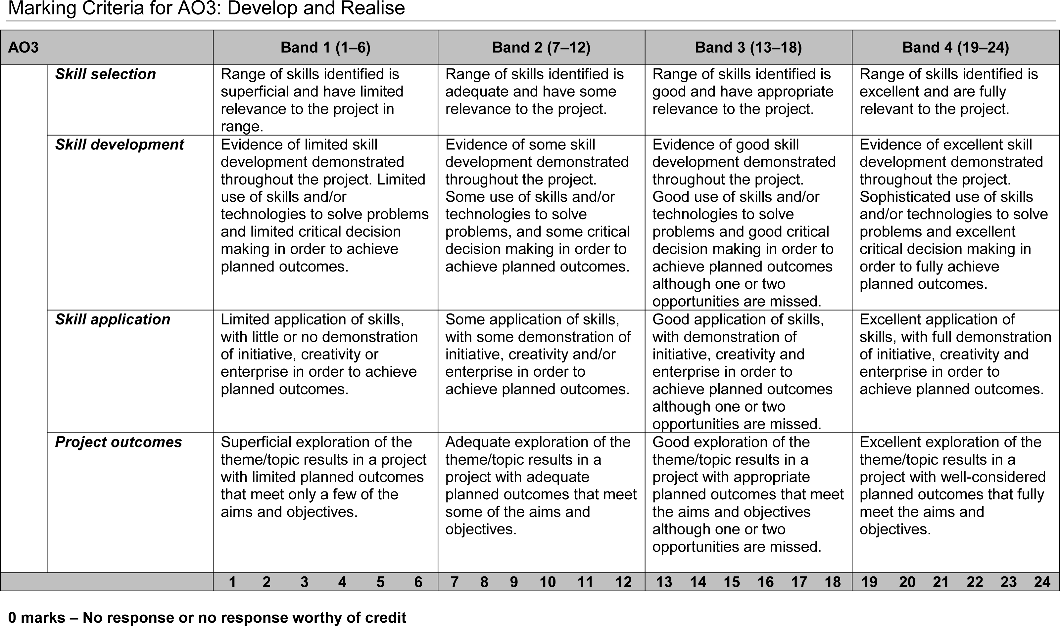

How are you demonstrating challenge?

How are you demonstrating skill gain?

How are you demonstrating Initiative?

How are you demonstrating enterprise?

What can you not see evidence of?

|  |
| --- |
| Assessment here:  -Need more sources (30 in total needed, so you need 25 more!) and need to evaluate sources  -Diary is not up to date  -No skills tracker and skills log  -No launch homework  -Project breakdown needed  -Start a bibliography |

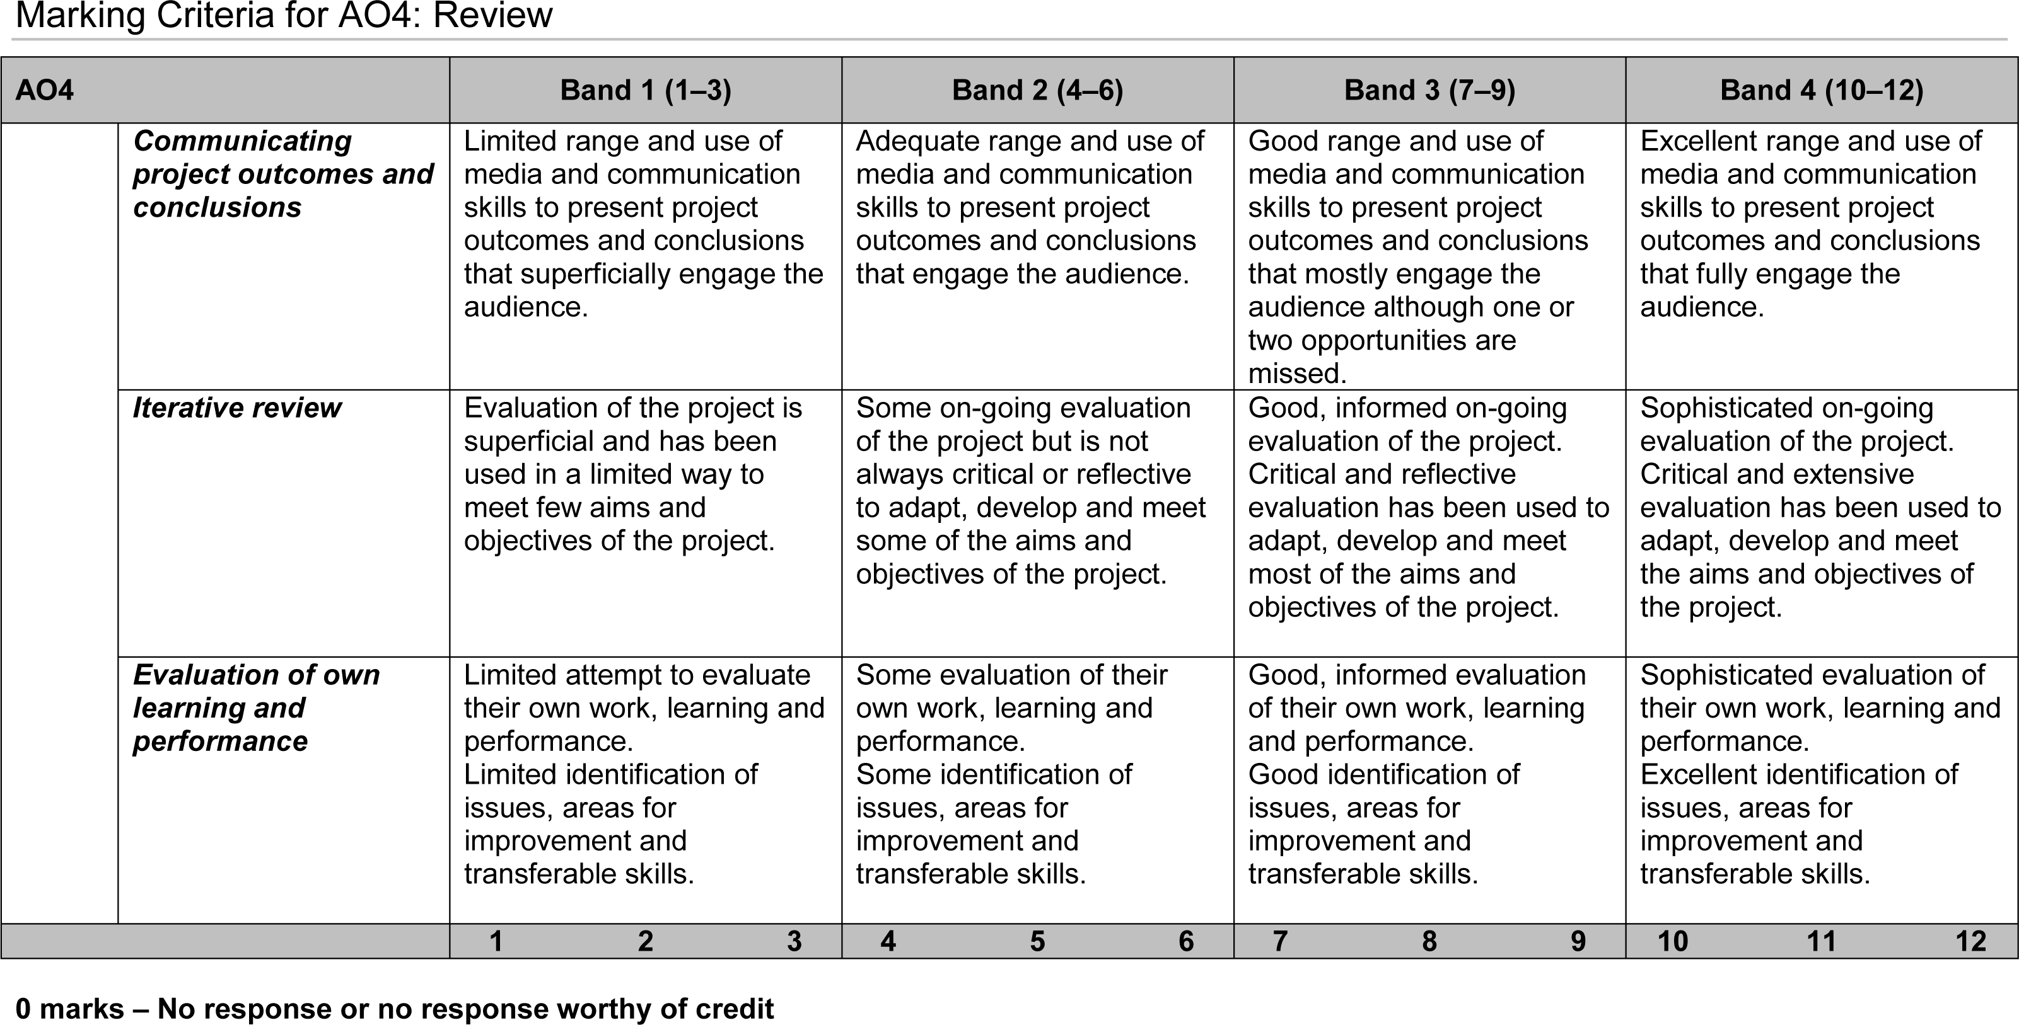

|  |
| --- |
| Assessment here:  -Need to add November review, Mid-project review, February review, Spring peer review |
| Response to assessment here: what will you change? |